IEEE Education Society Bangalore Chapter
Events conducted from IEEE Education Society for the year 2021
- Five Day webinar Jan-18th to 22nd on IoT and New Frontiers in Education in association with Spain and Portugal IEEE Education society chapters.
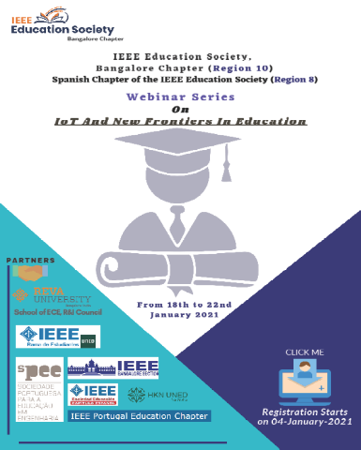

- Role of Engineers in Nation Building By Padmashri. R M Vasagam on 7.2.2021
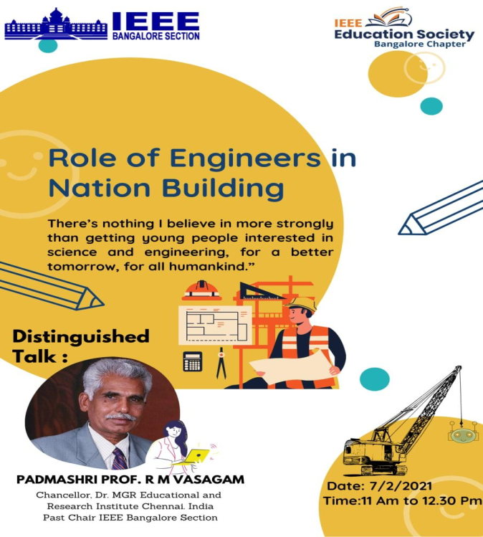

- National Innovation and Startup Policy 2019 for Student and Faculty –Demystified-21.2.2021 by Dr.K Nagabhushan Raju, Dean Faculty of Engineering and Technology, Sri Krishnadevaraya University, Anantapur, Andhra Pradesh
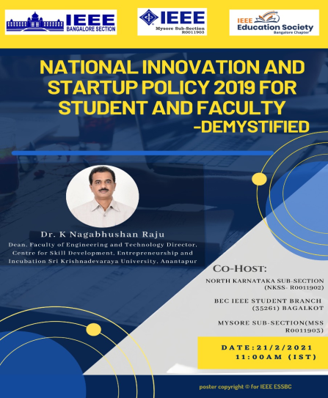

- Automation in Electronics Engineering 28.2.2021 by Ramachandra Gambheer, Sr.Leader, Business and Technicl Operations at Cisco Systems Inc, San Jose, California, USA
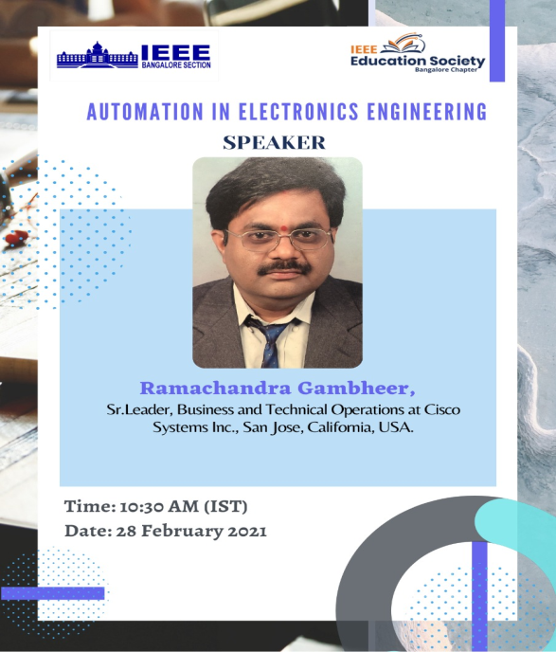

- Distinguished Talk on Homi J Bhabha: His Life and Legacy by Sharan Kalwani on 27.3.2021 from USA

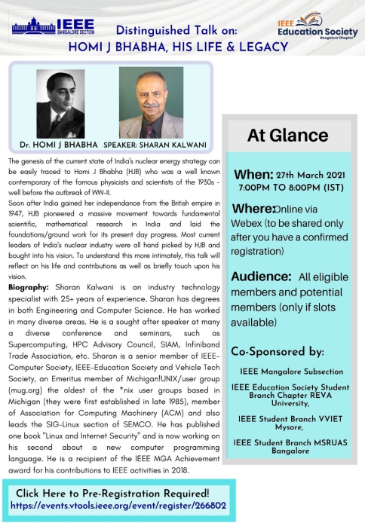

- Webinar on Critical Thinking Skills: Teach your students to think critically on 14.4.21 by Leslie Martinich from USA
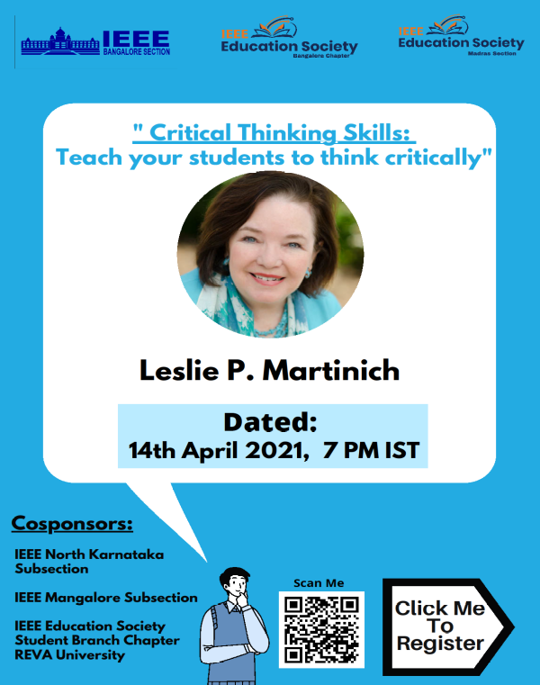
- Workshop on Security and AI Applications for 5G
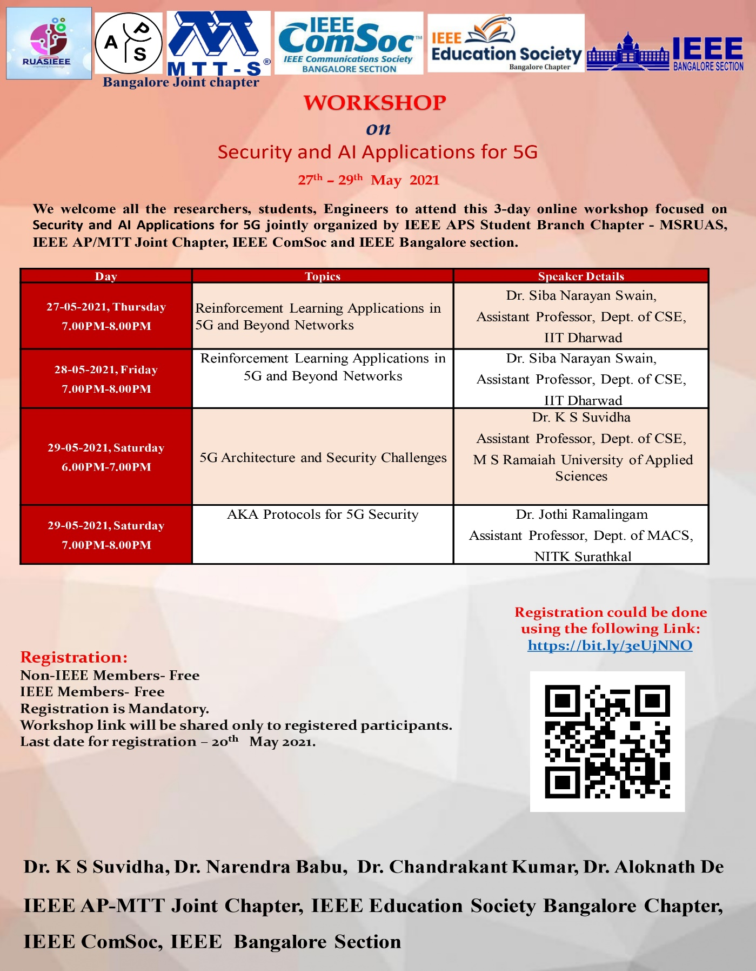

- Invited talk on “ Cloud Operations- Owerview and Challenges
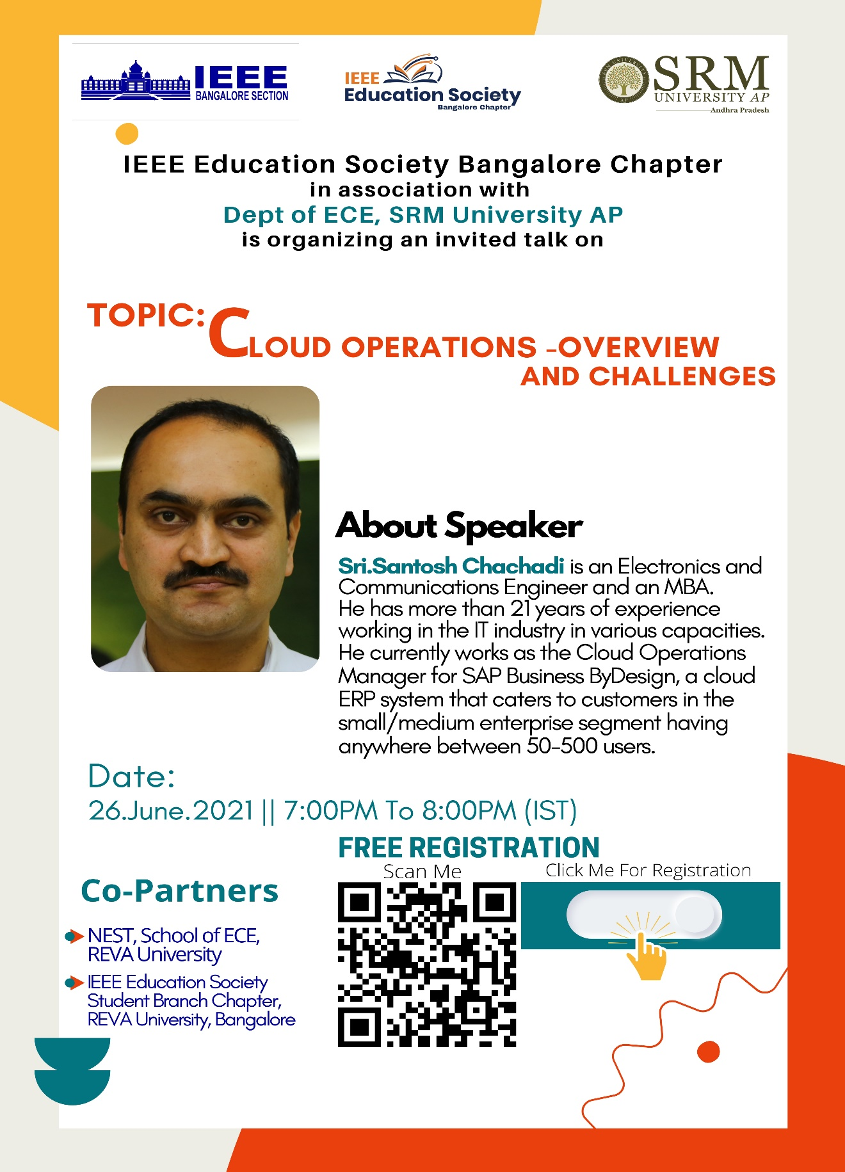
- Effective Virtual Class Tips & Tricks for Teachers
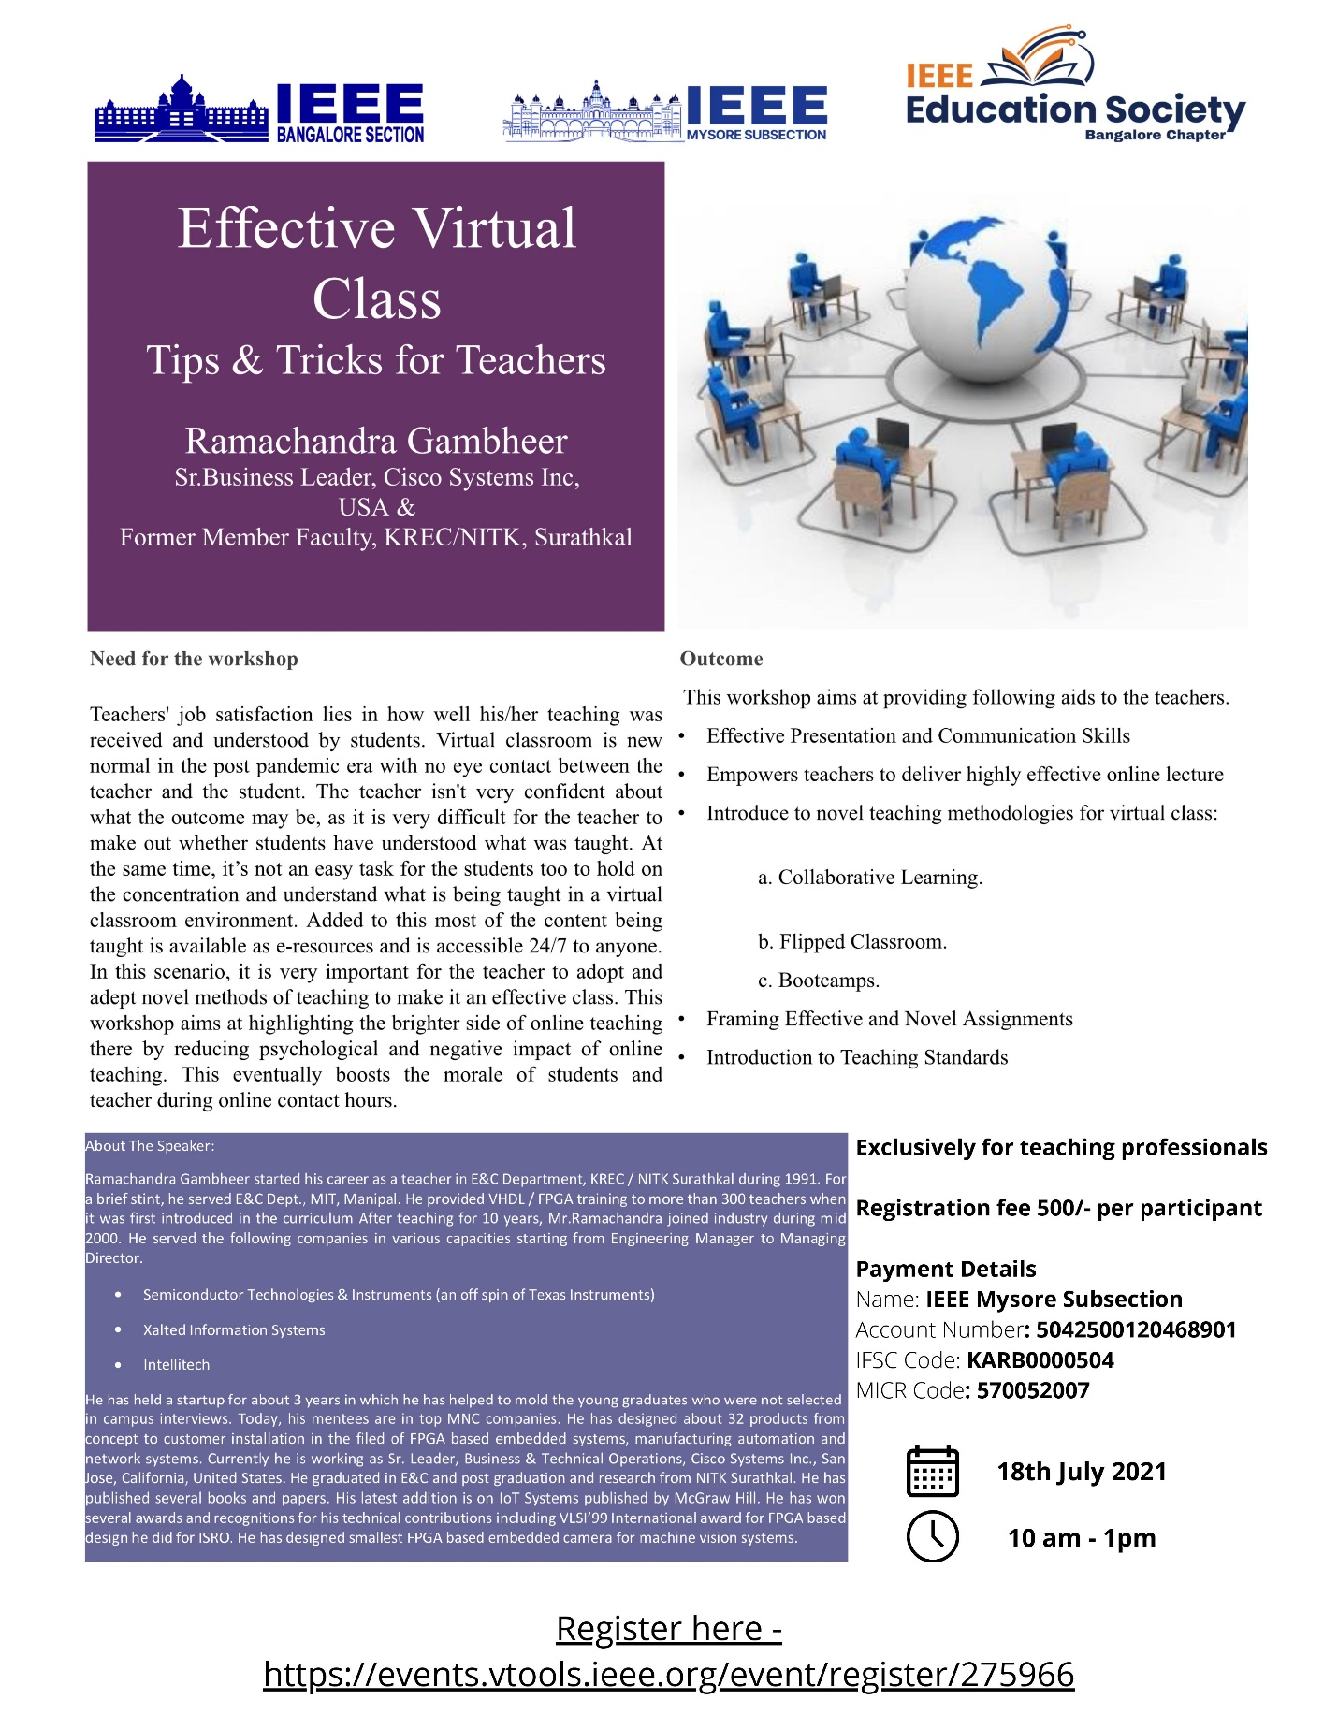
- Interactive webinar topic “ Preparing for Success”
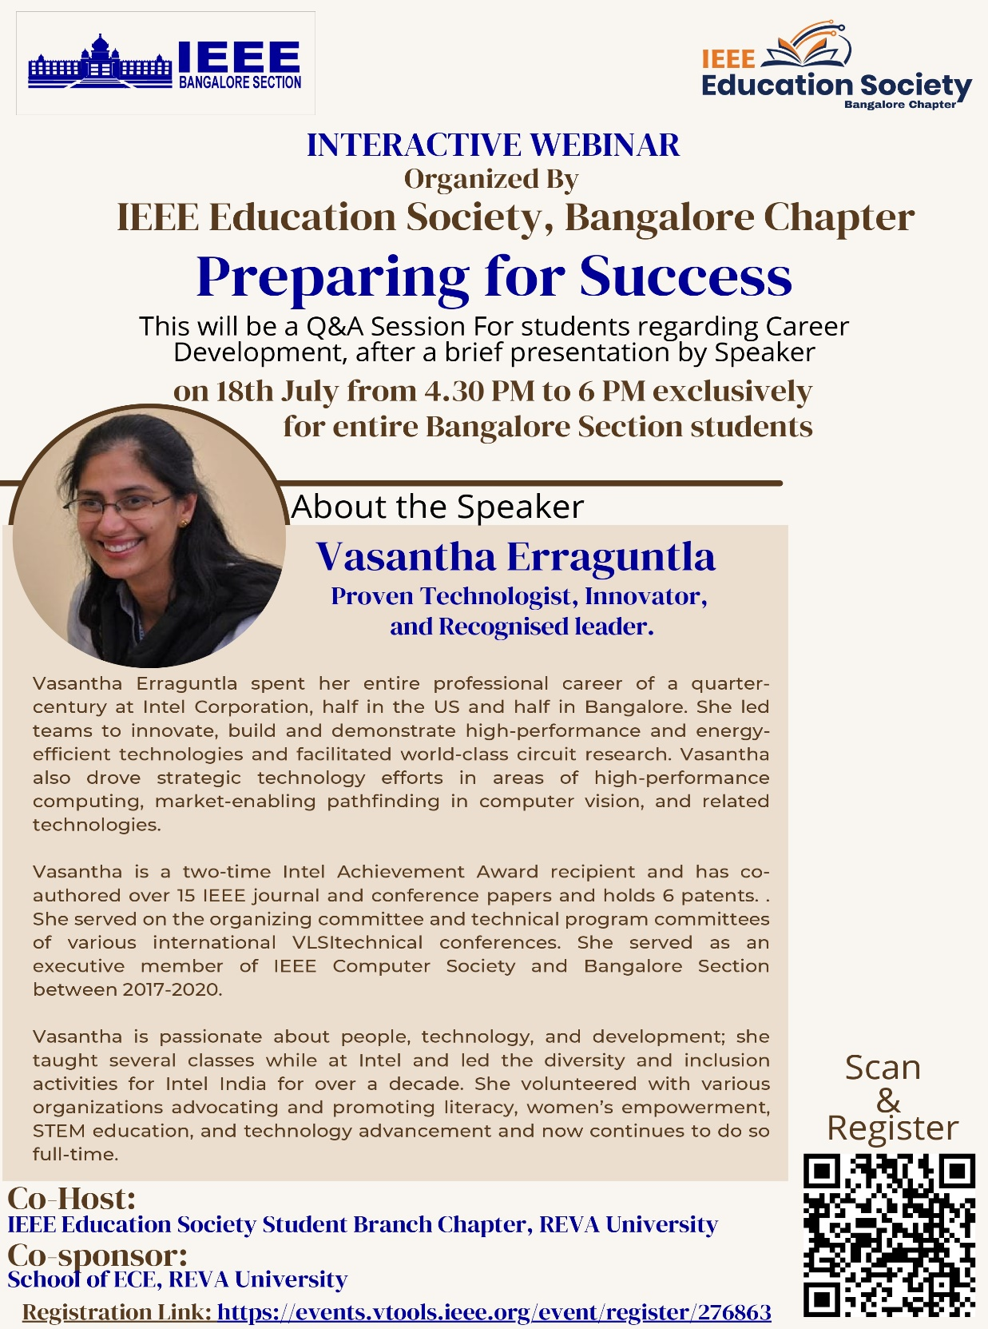

- Webinar on Indian Astronomy and Mathematics
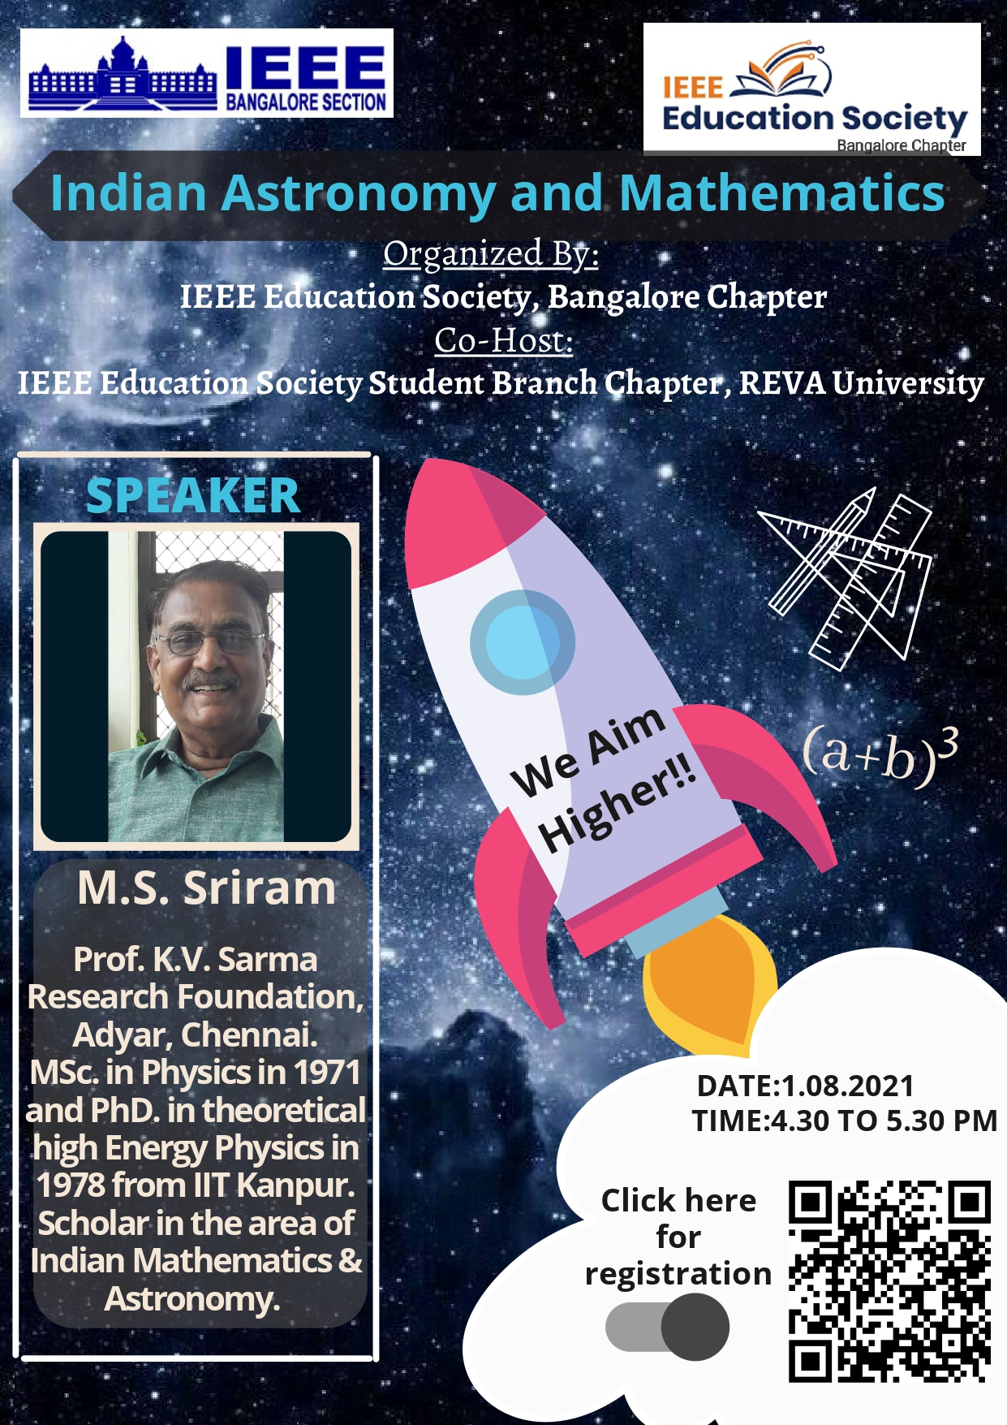

- Distinguished Talk on “ The Laws (rule of thumb may be) of Computing
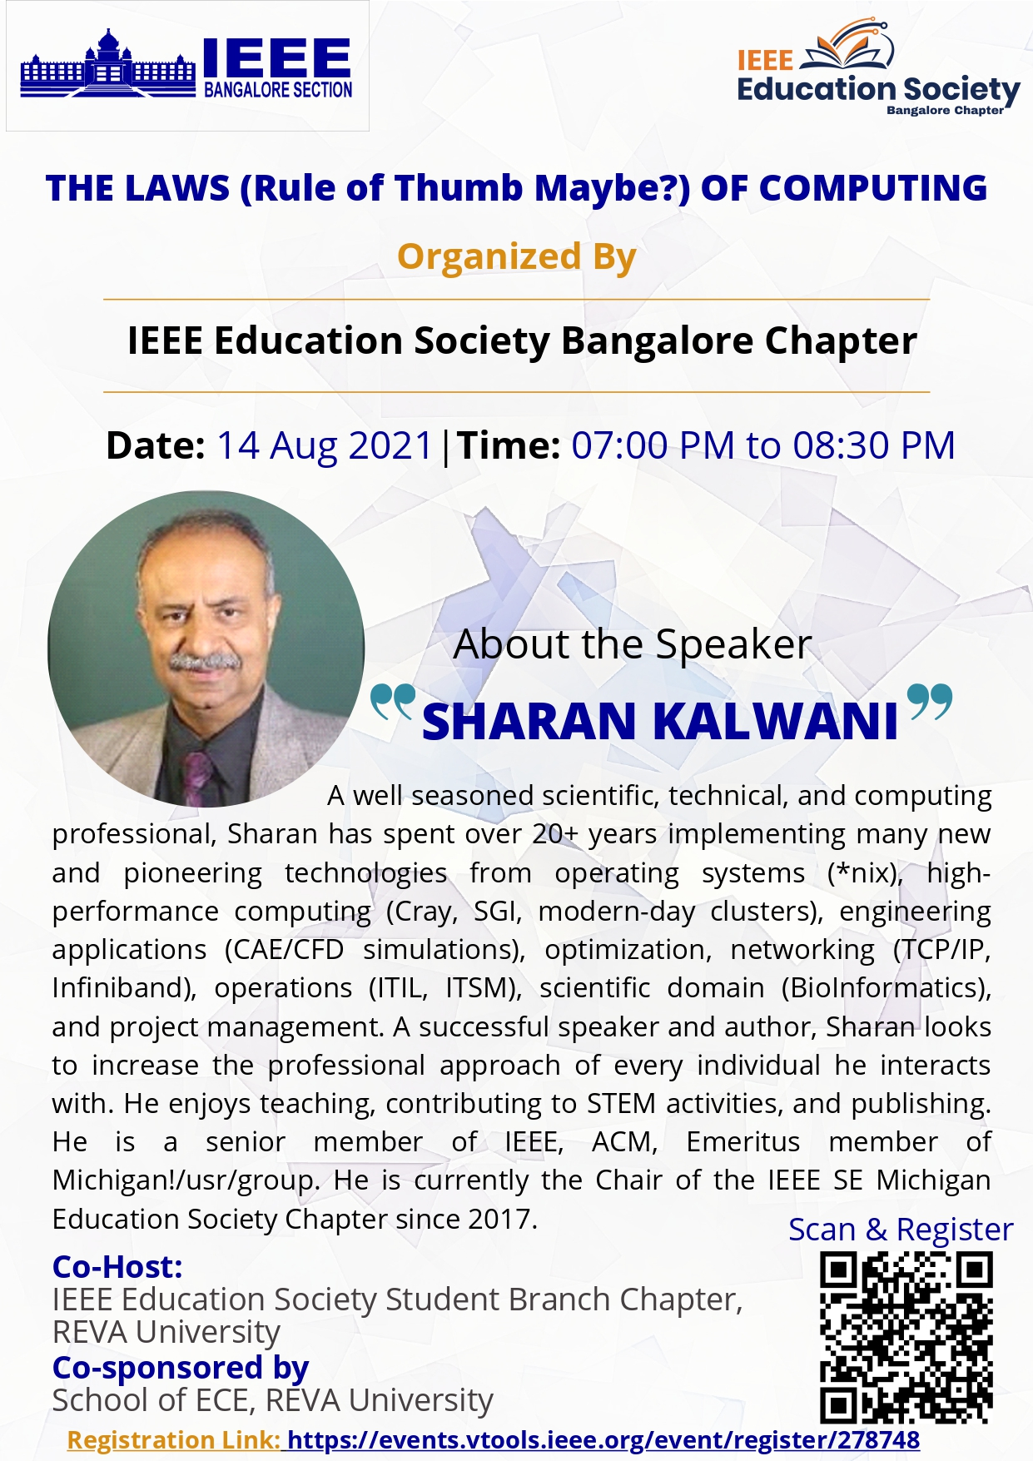

- Webinar on “ Technology Leaps in Indian Space and Societal Benefits”
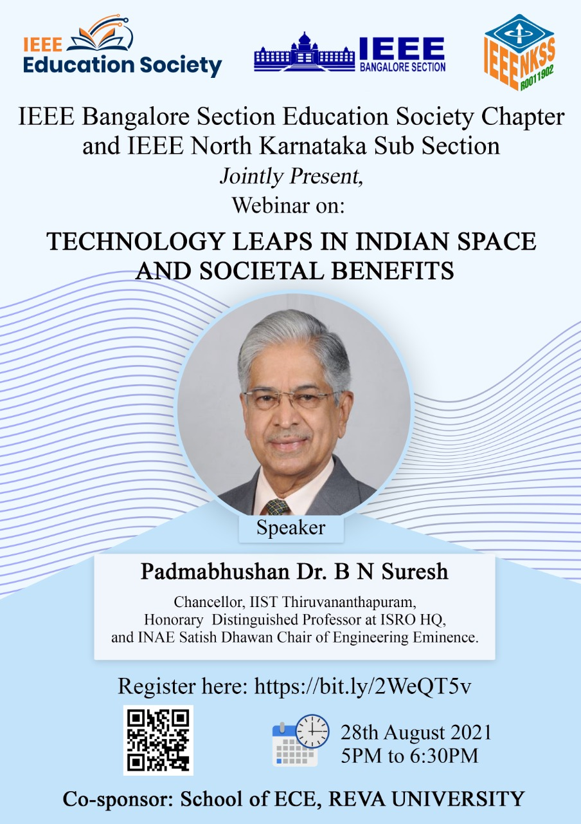

2021 IEEE Education Society Chapter Achievement Award
For contributions to the engagement and new international activities of the IEEE Education Society members in India.

