IEEE Education Society Bangalore Chapter
Activities Report-2022

IEEE Education Society Bangalore Chapter is the recipient of 2021 Chapter Achievement Award. This year we conducted various activities for the benefit of faculty and students.

The first program was organized in the month of March 2022. We conducted four week FDP for faculty members “Implementation of Service-Learning in Engineering Education” The program was scheduled on 5th, 14th, 21st, and 28th March. One hundred and six members registered and participated. The speaker was Dr.Rohit Kandakatla. He has completed his Ph.D. in Engineering Education from Purdue University and is currently serving as the Director for Strategy, Operations, and Human Resource Development at KG Reddy College of Engineering and Technology. He also has an adjunct faculty appointment with the Centre for Engineering Education Research at KLE Technological University.

The second program was organized in the month of May/June-2022. This was FDP on “Infusing Problem & Project Based Learning (P2BL) in Teaching and Curriculum as Envisioned in National Education Policy-2020” The program was scheduled on 14th May, 21stMay, 28th May, 4th June and 11th June-2022. Forty-two members participated in this FDP. The speaker was Dr.Deepak L Waiker, Chair of IEEE Education Society Singapore Chapter.

The third event was on September 16th. We conducted one distinguished talk “Enhancing STEM Students’ Engagement and Learning Outcomes with Innovative Pedagogy” Dr. Nalin Sharda, B.Tech. Ph.D. IIT Delhi Life Senior Member IEEE, Distinguished Lecturer IEEE Education Society. More than one hundred participants registered and participated in the distinguished talk.

The fourth event on 17th October distinguished talk “Leveraging the Megatrends “Digitalization for Sustainability in Industry 4.0” by Dr.Milan Kumar. Dr. Milan Kumar is an experienced CIO and CDO. He is a Global IT Leader, Technology & TEDx Speaker, International Author, Educator and Startups Mentor as well as a member of the Forbes Technology Council and part of Evanta Gartner CIO Governance Body.
IEEE Education Society Bangalore Chapter donated ten robotic kits to Gudibande (Chickballapur Dt.) Govt.High School children for improving quality STEM education. IEEE Education Society volunteers visit the school twice in a month and conduct Robotics hands on workshop to impart state of the art tech education at young age.
We also participated in the Bnagalore Section CONECCT-2022 conference and received 12 papers.

Date | Event  (virtual/offline) | Speaker/s Affiliation | Participants
5th, 14th, 21st, and 28th March | Implementation of Service-Learning in Engineering Education | Dr.Rohit Kandakatla from Purdue University | 106
14th May, 21stMay, 28th May, 4th June and 11th June-2022 | Infusing Problem & Project Based Learning (P2BL) in Teaching and Curriculum as Envisioned in National Education Policy-2020 | Dr.Deepak L Waiker, Chair of IEEE Education Society Singapore Chapter | 42
16.9.2022 | Enhancing STEM Students’ Engagement and Learning Outcomes with Innovative Pedagogy | Dr. Nalin Sharda, B.Tech. Ph.D. IIT Delhi Life Senior Member IEEE, Distinguished Lecturer IEEE Education Society | 102
17.10.2022 | Leveraging the Megatrends “Digitalization for Sustainability in Industry 4.0 | Dr. Milan Kumar is an experienced CIO and CDO. He is a Global IT Leader, Technology & TEDx Speaker, International Author, Educator and Startups Mentor as well as a member of the Forbes Technology Council and part of Evanta Gartner CIO Governance Body. | 82
28.10.2022 | STEM Hands on workshop. This is a year long workshop for 9th and 10th standard rural school children at Gudibande Chickballapur District. | IEEE Education Society Volunteers | 30

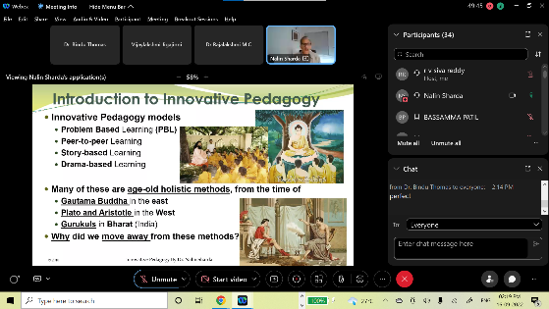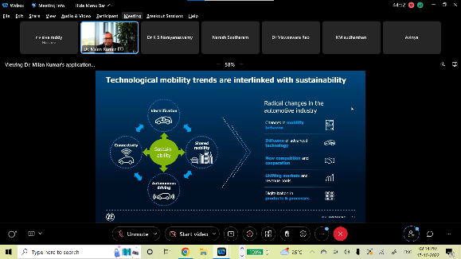
Distinguished Talk by Dr.Nalin Sarda Distinguished Talk by Dr.Milan Kumar

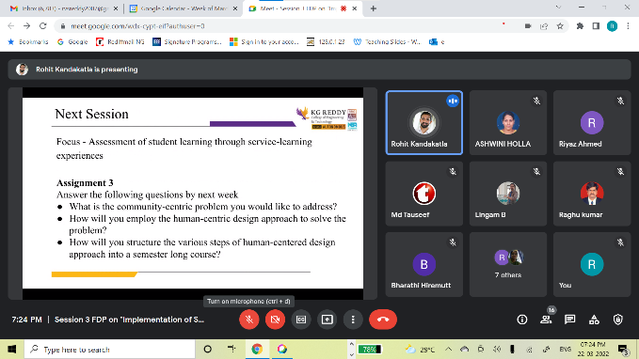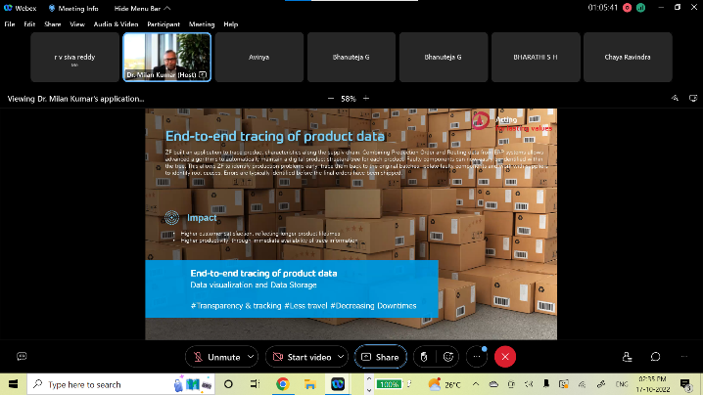
FDP by Dr.Rohit Kandakatla Distinguished Talk by Dr.Milan Kumar

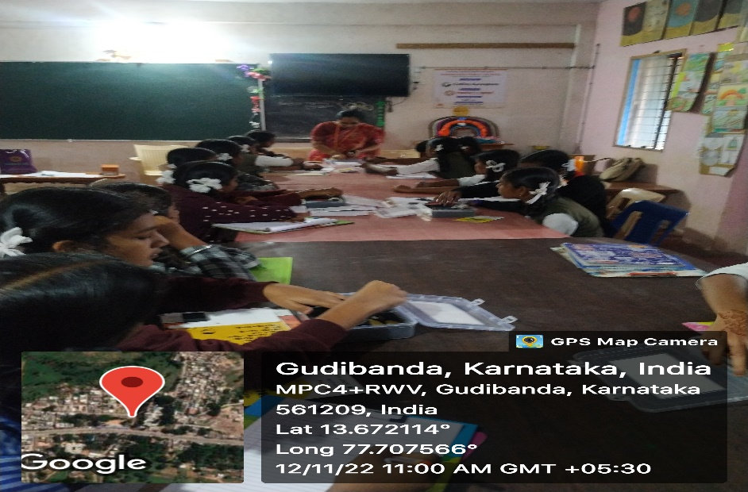
STEM Hands on Workshop

